NHS Test & Trace, Local Enhanced Contact Tracing and Community (Mass Asymptomatic) Testing

- Purpose of report

The purpose of the report is to update the Committee in relation to NHS Test and Trace, local enhanced contact tracing and community (mass asymptomatic) testing.

Introduction

On 23rd November 2020 the Government published the COVID Winter Plan - https://www.gov.uk/government/publications/covid-19-winter-plan that provides a route map out of the COVID pandemic within a 3-6 months' timeframe.
The national situation is that testing capacity for those with COVID-19 symptoms has increased almost five-fold in six months, from 100,000 a day at the end of April to 500,000 a day by the end of October, with plans to go even further by the end of the year. Altogether, over 37 million tests have been conducted1, opened over 680 test sites, reducing the median distance travelled for a test to 2.4 miles2.
The increase in testing capacity has been supplemented by work to improve contact tracing. In the last week of reported figures (19 to 25 November) 116,324 people were transferred to the contact tracing system, 84.9% of those were reached and asked to provide information about their contacts and 72.5% of those contacts whose details were provided responded to notifications asking them to self-isolate3. Work to improve contact tracing continues, including the roll-out of tracing partnerships with Local Authorities (LA) to ensure a greater proportion of people who have tested positive are reached, help provide the support they and their families need to self-isolate successfully and more quickly, and identify and reach any contacts they have had outside their immediate household. In addition, the NHS COVID-19 app has been downloaded 20 million times, and this is supporting the contact tracing effort, including through use of the QR code check-in capability.

- NHS Test and Trace

The flowchart below illustrates how people move through NHS Test & Trace:
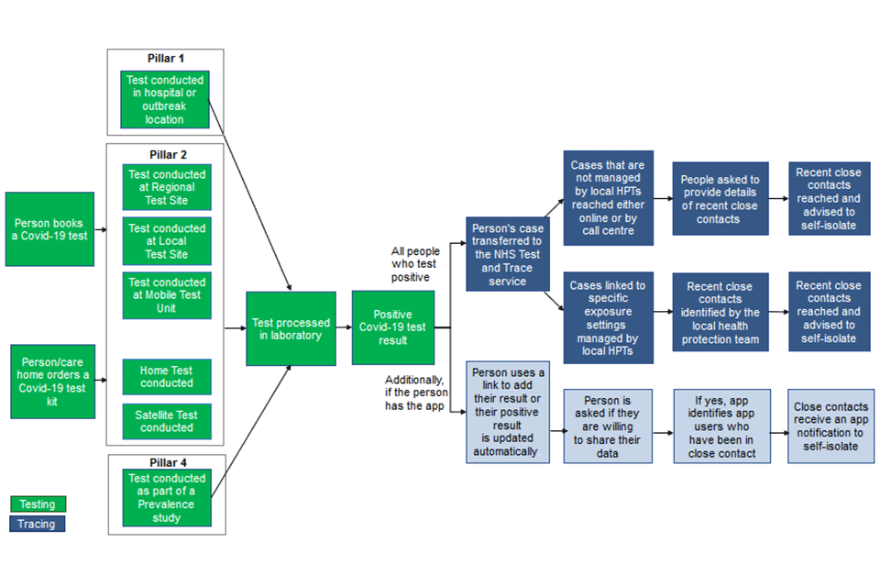

The COVID winter strategy is backed by an additional £7 billion for NHS Test and Trace to support increased testing, including community testing and ongoing improvements to tracing, taking the overall funding provided for Test and Trace this financial year to £22 billion. Government has provided resource allocations at £8 per head population directly to districts for prioritisation of spend in this area plus other streams of funding for COVID marshals.

3.1 National NHS Test & Trace Enhancements:

To improve Contact Tracing and Advice Service (CTAS) data flow between the national and local level for Local Tracing Partnerships in order to minimise delays to contact tracing, improve performance and performance monitoring the following enhancements are in progress or have been implemented.

- Develop a CTAS view for LAs where cases can be transferred to LA directly in CTAS in real time. This will remove the need to use Power BI (business intelligence platform by Microsoft) dashboard for case listing, reduce delays associated with dashboard data transfer and help LA manage their cases in a timely manner.
- Introduce a new CTAS outcome for local contact tracing, indicating local follow-up is needed by LA contact tracers. This will improve monitoring of progress and performance of contact tracing at local level.
- Develop a return flag to enable records to be returned from local to national level.

Effect of change:
- LA contact tracers will receive cases directly in CTAS in real time. Power BI dashboard will no longer be used for case referrals. LAs will manage and regulate their workload directly in CTAS including returning excessive cases.

Expected Benefits:
- More timely receipt of index cases by LAs
- Increased efficiency of LA contact tracers to manage their workload.
- Reduced delays to transition of cases from national to local level and delays to potential return of cases to national level.
- Improved monitoring of local follow-up progress and performance.

The change will be implemented in 2 phases:

- Phase 1: Creating a new status for Local Authority will be ready for deployment 2nd December
- Phase 2 will be ready for deployment on the 16th December and will cover
  - New local authority pages and records
  - Ability to download CSVs (comma-separated value file/spreadsheet) for Local Authority records

Household Segmentation (De-duplication):

With effect from Saturday 28th November 2020 an index case will be able to provide the required details of contacts in their households and take responsibility to advise the contacts to isolate – these contacts can then be marked as complete and will not need to be separately invited for the digital journey.

3.2 Local Enhanced Contact Tracing – Positive Case Completion:
Local Enhanced Contact Tracing is whereby Local Authorities voluntarily opt to have positive cases directed to local contact tracing teams after a period of 24 hours if the national Tier 2 NHS professionals call handlers are unable to make contact. This activity is positive case completion, and now index cases can provide details of their contacts and be marked as complete (national enhancements). Currently across Lancashire the two upper tier authorities (Blackburn with Darwen and Blackpool) and ten districts have local enhanced contact tracing arrangements. Fylde has agreed a sub contractual agreement with Blackpool Council to carry out their local contact tracing for their residents and Ribble Valley is progressing well. Both Fylde and Ribble Valley are planned to go live early to mid December 2020 through a national assurance process. Communication on COVID information and data is available at: https://www.lancashire.gov.uk/health-and-social-care/your-health-and-wellbeing/coronavirus/ and districts have COVID pages for residents including self isolation support and testing locations.

Lancashire has been actively influencing the national NHS Test & Trace programme and national leads to make the best of our respective national and local synergies whilst recognising there are no plans to fully localise local contact tracing for Lancashire residents.

3.3 NHS Test & Trace – Lancashire Performance Data:

The latest performance data for NHS Test and Trace available at https://www.gov.uk/government/publications/nhs-test-and-trace-england-and-coronavirus-testing-uk-statistics-19-november-to-25-november - also see Annexe 1. The Lancashire data for NHS Test & Trace 28th May – 25th November 2020 shows the following performance:

 | Total | Total reached | % reached
People transferred to contact tracing system | 43197 | 37208 | 86
Contacts identified who were not managed by local health protection teams | 90403 | 52348 | 58

The Government Scientific Advisory Group for Emergencies (SAGE) advice is that for NHS Test and Trace to be fully effective 80% of contacts of positive cases would have to be contacted within 48 hours. Provisional data analysis indicates the results below for Lancashire areas.

National NHS Test & Trace test turn around performance:

- Test Turn around no percentages are readily available but the Median Times are as follows for October and November.
  - All test channels:
    - October: 46.5 hours
    - November: 32.1 hours
  - In-person test channel:
    - October: 36.2 hours
    - November: 25.0 hours
- Time taken for test results to reach CTAS (No data available). This is a transfer between two data systems, this takes less than 24 hours, usually a few hours and occurs several times per day.

National NHS Test & Trace Lancashire performance:

- Time taken to complete cases from the point it reaches CTAS
Cases Reached within 48hrs from being entered in to CTAS System:
October 2020:
  - Lancashire Average: 67.7%
    - Min LA: 58.8%
    - Max LA: 76.3%
November 2020
    - Lancashire Average: 74.8%
      - Min LA: 58.8%
      - Max LA: 76.3%
Contacts Reached within 48hrs of being entered in to CTAS system:
October 2020:
    - Lancashire Average: 53.0%
      - Min LA: 47.9%
      - Max LA: 58.2%
November 2020
    - Lancashire Average: 57.7%
        - Min LA: 51.1%
        - Max LA: 64.0%

- Outline of current testing strands including the latest community (mass asymptomatic) testing

Testing is a key pillar of the strategy to protect the NHS, social care and save lives. There are 2 types of tests:

- ‘swab tests’ for people with symptoms to see if they have coronavirus, and
- ‘antibody tests’, which test for the presence of antibodies that will demonstrate whether you have had the disease

There are five pillars of the Government COVID testing strategy (Figure 1), as follows:

Figure 1: COVID19 Testing – 5 Pillars
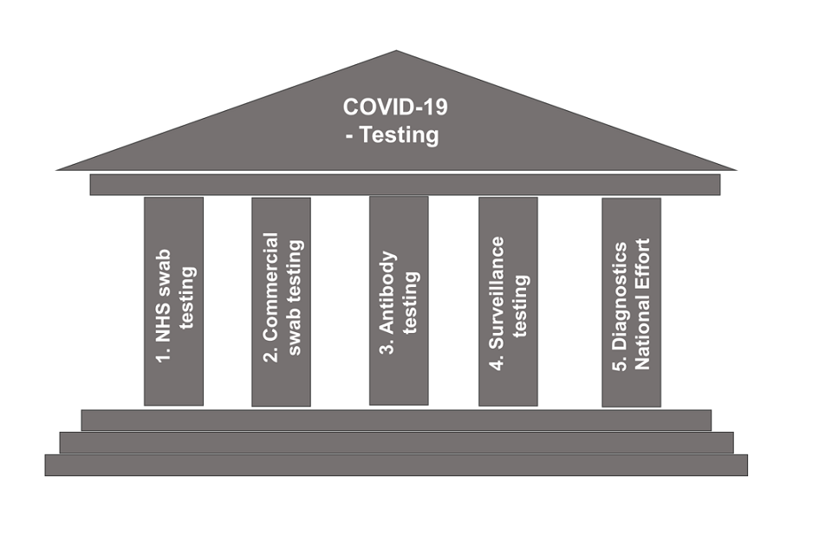

Pillar 1 - Scaling up NHS swab testing for those with a medical need and, where possible, the most critical key workers

Pillar 2 - Mass swab testing for critical key workers in the NHS, social care and other sectors

Pillar 3 - Mass antibody testing to help determine if people have immunity to coronavirus

Pillar 4 - Surveillance testing to learn more about the disease and help develop new tests and treatments
- Pillar 5 - Spearheading a Diagnostics National Effort to build a mass-testing capacity at a completely new scale

Information for clinical diagnostic laboratories regarding safety, sampling and packaging specimens associated with COVID-19 is available at https://www.gov.uk/government/publications/wuhan-novel-coronavirus-guidance-for-clinical-diagnostic-laboratories

4.1 Community (Mass Asymptomatic) Testing:

The community testing programme will offer Local Authorities in tier 3 areas the opportunity to participate in a six week testing surge using Lateral Flow Tests. This will enable Local Authorities to offer tests to the general population as well as targeting high-risk workplaces and industries, hard-to-reach communities and schools in a coordinated effort to drive prevalence down. It will be delivered in partnership with Local Authorities to ensure it is tailored to local circumstances and need. The immediate priorities for the expansion in asymptomatic testing are laid out in Figure 2 below. They are based on areas where the most vulnerable in society need to be protected and where more positive cases are expected to be found.

A community testing guide for local delivery with details of the programme are available at: https://assets.publishing.service.gov.uk/government/uploads/system/uploads/attachment_data/file/939957/Community_rapid_testing_prospectus_FINAL_30-11.pdf

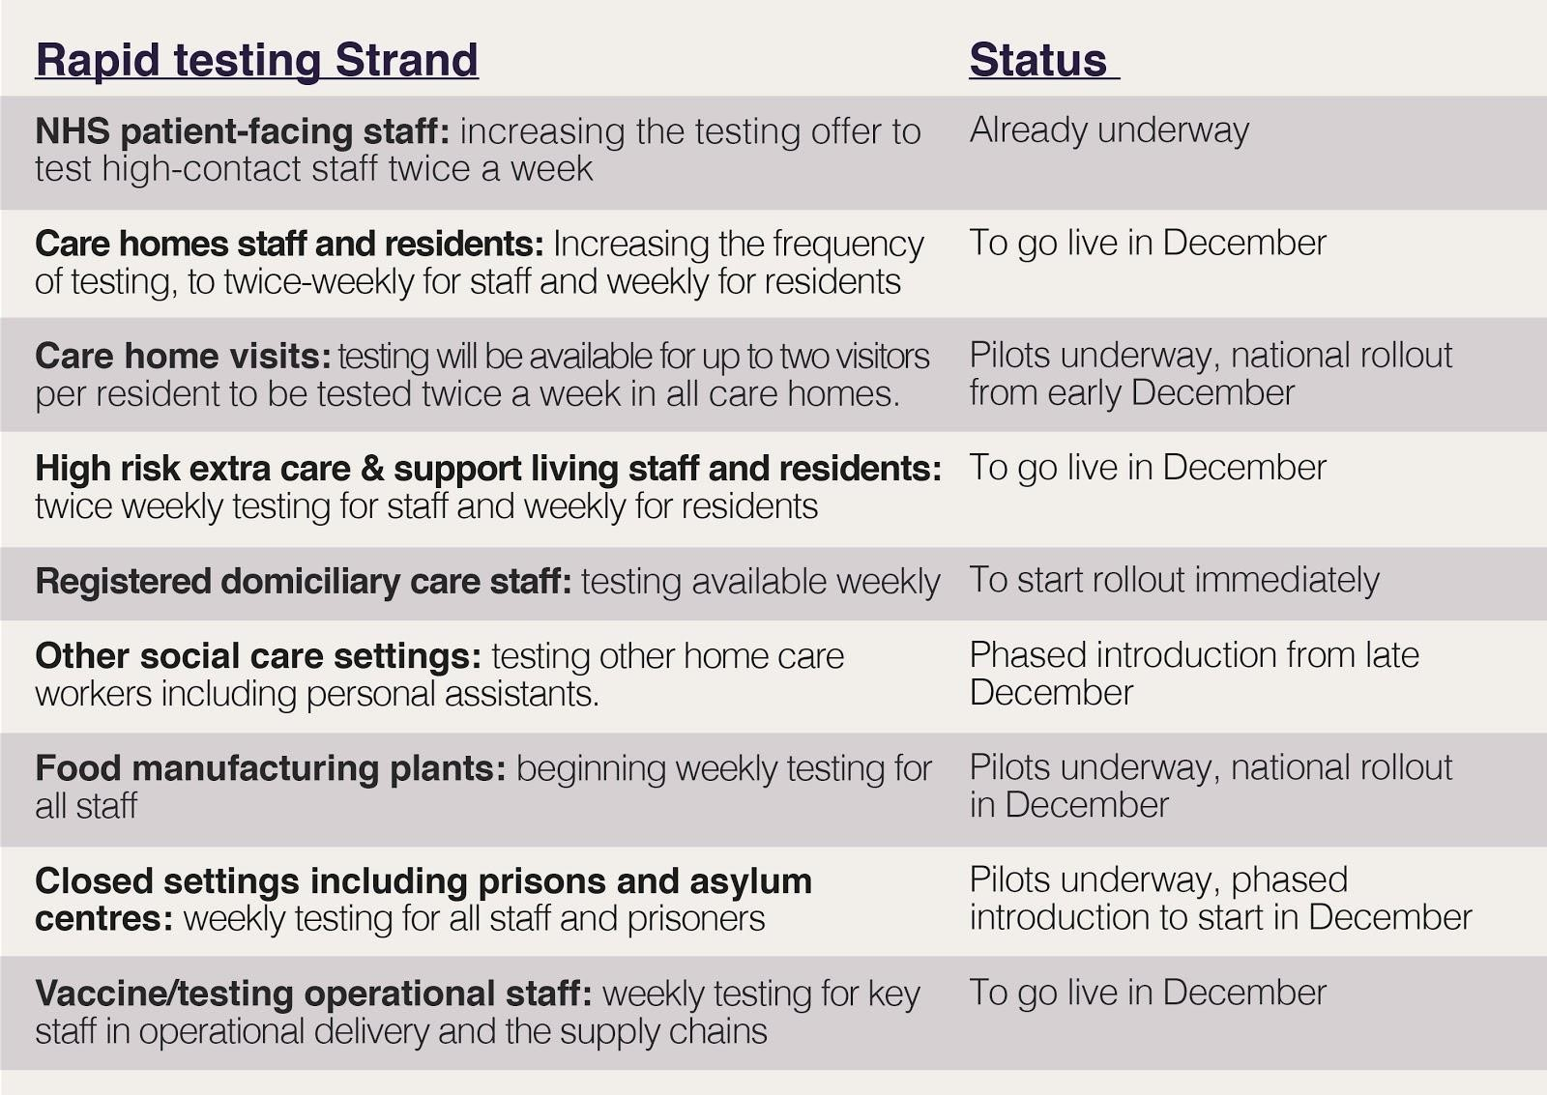
Figure 2: Expansion of testing Status of rapid testing workstreams

To date, testing has focused on symptomatic testing, testing in areas with outbreaks and protecting those most at risk, for example in care homes. Those efforts will continue but the use of testing is now being broadened to identify those showing no symptoms who can infect people unknowingly. Regional testing pilots in Liverpool (over 100,000 people tested at asymptomatic test sites)4 and Merthyr Tydfil have trialled offering rapid tests to a wider population and Government have indicated that are making a contribution to a fall in positive cases alongside other measures.

4.2 Care Home Visiting:

The launch of visitor testing is a crucial step to making that happen and this approach is currently being piloted in 20 care homes. The Government is committed, by Christmas, to providing twice weekly testing to enable all care home residents to have regular visits from up to two visitors. If a visitor has a negative test, is wearing appropriate PPE, and follows other infection control measures, then it will be possible for visitors to have physical contact with their loved one, such as providing personal care, holding hands and hugging.

4.3 Schools, Colleges, Universities:

The Government will continue piloting further rapid testing in schools, colleges and universities, and will deploy rapid testing for specific one-off events. This includes testing university students before they travel for Christmas, starting from 30 November, as well as supporting universities to establish sustained testing regimes.
For Universities to support all students being able to travel home in the window, face to face provision for the winter term should finish at every provider by 9 December. Those who do not return home by 9 December will be advised to undertake a further period of restricted contact either before or after returning home to minimise the risk of transmission. It is expected providers to stagger the end of face to face provision between 3 to 9 December between faculties.

Guidance on student movement at end of term is available at: https://www.gov.uk/government/publications/higher-education-reopening-buildings-and-campuses/student-movement-and-plans-for-the-end-of-autumn-2020-term

Lancashire CC Public Health is working with local Universities with the rollout of rapid testing from week commencing 30th November 2020 to allow safe return home of Lancashire University students.

4.4 International Travel:

It is also important to manage the number of cases seeded from abroad. The Government has introduced public health measures at the border including a 14-day isolation period for international arrivals, and introduced the travel corridors system to limit these requirements to those countries with higher prevalence.

A Test to Release scheme is now available from 15th December 2020 for international travelers returning to the UK - https://www.gov.uk/guidance/coronavirus-covid-19-test-to-release-for-international-travel. Under the scheme you can choose to pay for a private COVID-19 test. The earliest you can take the test is at least 5 days after you left a destination not on the travel corridor list. If the result is negative, you can stop self-isolating. The scheme is voluntary and applies to those self-isolating in England only.

4.5 Self Isolation:

The Government plans to introduce frequent testing as an alternative to the need for self-isolation for people who have had close contact with someone who has COVID-19. Instead, contacts will be offered regular tests as an alternative to isolation and only have to self- isolate if they test positive. This will be trialled in Liverpool first, then some institutional settings (e.g. the NHS, care homes, education, employers) before the end of the year, ahead of rollout across the country from early next year. Lancashire provides self isolation payments of £500 to eligible residents where a NHS Test & Trace ID number can be provided.

4.6 New Testing Technologies:

The Government has been working to validate new testing technologies, and there are now three main forms of test in addition to PCR (polymerise chain reaction) swab tests which are available for deployment: lateral flow devices, LAMP (Loop Mediated Isothermal Amplification) and LamPORE. Lateral flow devices are already available at significant scale, and so are the focus of our near-term expansion of rapid testing.

  - Mass Vaccination

The Joint Committee on Vaccination and Immunisation (JCVI) advises that the first priorities for any COVID-19 vaccination programme should be the prevention of COVID-19 mortality and the protection of health and social care staff and systems. Secondary priorities could include vaccination of those at increased risk of hospitalisation and at increased risk of exposure, and to maintain resilience in essential public services. The link to https://www.gov.uk/government/publications/priority-groups-for-coronavirus-covid-19-vaccination-advice-from-the-jcvi-2-december-2020/priority-groups-for-coronavirus-covid-19-vaccination-advice-from-the-jcvi-2-december-2020 sets out a framework for refining future advice on a national COVID-19 vaccination strategy.

References:

1 Public Health England & NHSX, Testing in United Kingdom, November 2020, https://coronavirus.data.gov.uk/details/testing

2 Department of Health and Social Care, Test and trace weekly stats (19-25 November), November 2020 https://www.gov.uk/government/publications/nhs-test-and-trace-england-and-coronavirus-testing-uk-statistics-19-november-to-25-november

3 Department of Health and Social Care, NHS Test and Trace Weekly statistics, November 2020 https://www.gov.uk/government/publications/nhs-test-and-trace-england-and-coronavirus-testing-uk-statistics-19-november-to-25-november

4 BMJ, November 2020 https://www.bmj.com/content/371/bmj.m4460

Annexe 1: National COVID and NHS Test & Trace Data
Gov. UK Coronavirus – current and beta
PUBLIC ACCESS
https://coronavirus.data.gov.uk/
Data on tests, cases, healthcare and deaths published by PHE daily 4pm.
Positive cases and deaths at UTLA/LTLA
Middle Super Output Area (populations 5-15k, average 6.5k homes. 7-day rolling cases Updated daily
Daily COVID-19 Containment dashboard
RESTRICTED AND AUTHENTICATED ACCESS TO LA LEADERS INCLUDING CXs, DPHs AND EXPANDING TO MAYORS, HEALTH LEADERS, DISTRICT COUNCILS

Pillar 2 Test Data, 111 telephony and online triage information and positive cases. Data is presented at combination of UTLA level LSOA level and Postcode level Data
Launched 11 June 2020

PHE DPH and LA Portal
DATA SHARING AGREEMENT AS PERSONALLY IDENTIFIABLE
Data uploaded daily by PHE
Record level test, case and contact tracing data
Schools Helpline data
Outbreaks, clusters and settings data
Modelling and forward plans

NATIONAL DATA – PUBLIC ACCESS
Daily statistics on gov.uk - tests, cases, deaths – (pre release email to key recipients in place) – New version with R and Growth Rate, alert level, better navigation to local data by postcode, integrated map with UTLA (upper tier local authority), LTLA (lower tier local authority), MSOA (middle super output area)
Weekly NHS Test and Trace stats – people tested, positive cases (both by demographic characteristics), testing turnaround, contract tracing (UTLA), NEW includes testing in care homes & the NHS COVID-19 App
Weekly surveillance report – positive cases by various demographics plus NEW lower tier local authority watch list with epidemiological data added as a standalone product 23 October 2020

- COVID data in the public domain - https://www.local.gov.uk/sites/default/files/documents/PHE%20-%20Data%20in%20the%20public%20domain.pdf
- Weekly NHS Test & Trace reports: https://www.gov.uk/government/collections/nhs-test-and-trace-statistics-england-weekly-reports
- Local alert levels - https://www.gov.uk/guidance/local-restriction-tiers-what-you-need-to-know

